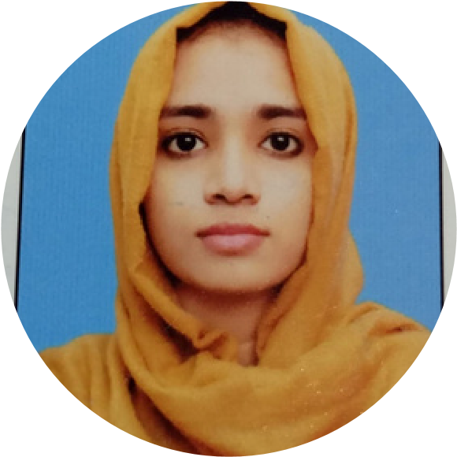
NAVERIA SUMAN
BS Computer Science Student
UI/UX Projects
Activities
Self-made mobile ap
p interface
.
,
g
Self-desi
ned travel website conce
pt with structured content
visual hierarchy
.
Self-designed professional networking/skill-platform website
concept inspired by the idea by the connecting people
around.
(
still working on it
)
Motivated

BSCS student with completed UI/UX design training
and hands-on experience creating original interface concepts
in Figma. Seeking an internship opertunity to apply and
enhance my technical skills in a professional environment.
Eager to contribute and grow through hands-on experience.
Noodles Mobile App
Travel Website
Skillswap Website
naveria2004@gmail.com
+92 3708058577
Street no 1, shamsabad, Madni
colony, Jumrah RD,Fsd.
Contact
Education
Technical Skills
BS Computer Science

Government College University
Faisalabad.

2024-
Present.
Programming :
C++, Python, CSS,
HTML, Javascript
Database:
MongoDB
Networking
:
Computer networking,
Cisco packet Tracer
UI/UX Skills
Figma:
UI design, components &
prototypes.
UI design:
Layout, spacing,
typography and visual.
UX:
Usabilty-focused interface
thinking.
Other Projects
Member, IEEE Student Branch, GCWUF
Member, Art and Culture society, GCWUF
Doing online internship at HYVER Technology

Student Portal
Developed a web-based student portal to manage
academic records and student information.
Quiz Website
Built an interactive quiz application using Python with
dynamic question loading and score tracking.
Library Management System
Designed and implemented a Library Management System
using MongoDB for efficient data storage and retrieval.

